Table of Contents

Installation Guide 3

Build the back-end solution 3

Build the front-end solution 4

Task 1 - Race Dashboard 5

Race status 5

Total amount of money for each race 5

All horses per race with name, bet count and winning prize 5

Task 2 - Additional Endpoints 6

List of customers 6

Total bet count per customer 6

Total bet amount per customer 6

Total bet amount for all customer 6

At risk customers (with bets more than $200) 6

Tests 7

TechChallenge.Tests.Unit 7

TechChallenge.Tests.Integration 7

Solution Architecture Overview

In bird’s eye view, the solution is separated into 3 different areas namely: **Business**, **Hosts** and **Tests.**

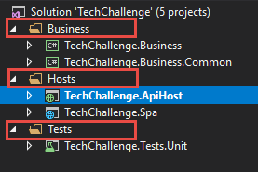

The solution is built using Visual Studio 2017

– with .Net 4.6.2 and Angular 8

# Installation Guide

## Build the back-end solution

Set start-up Project

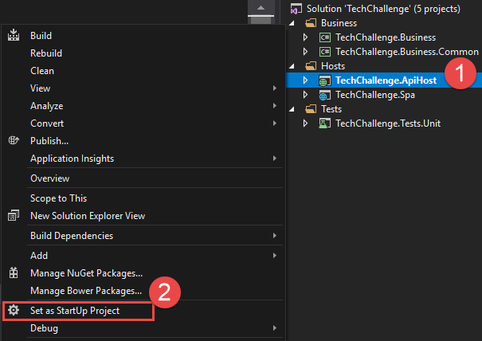

Press F5 to view the WebApi documentation via swagger

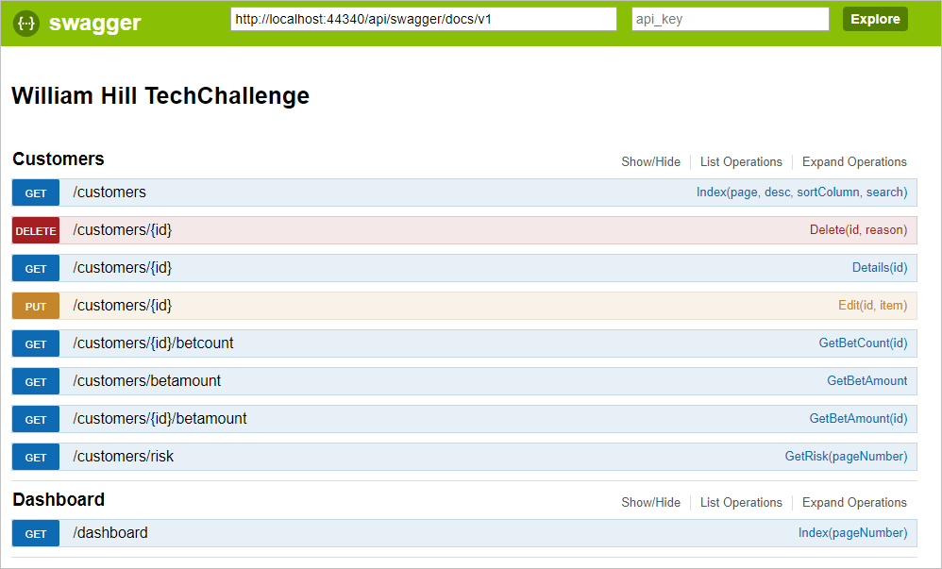

## Build the front-end solution

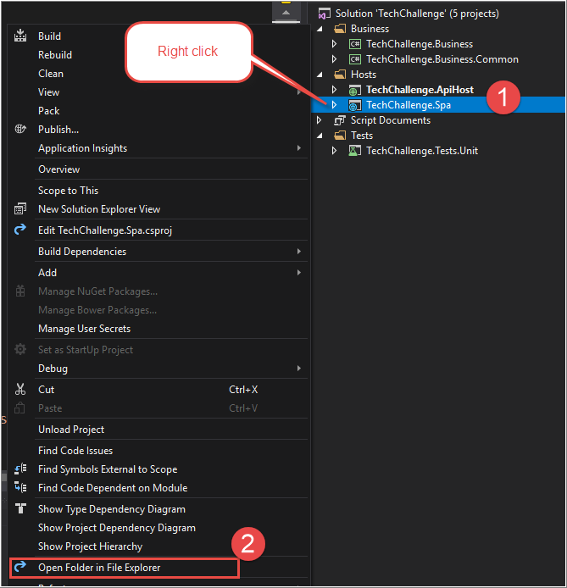

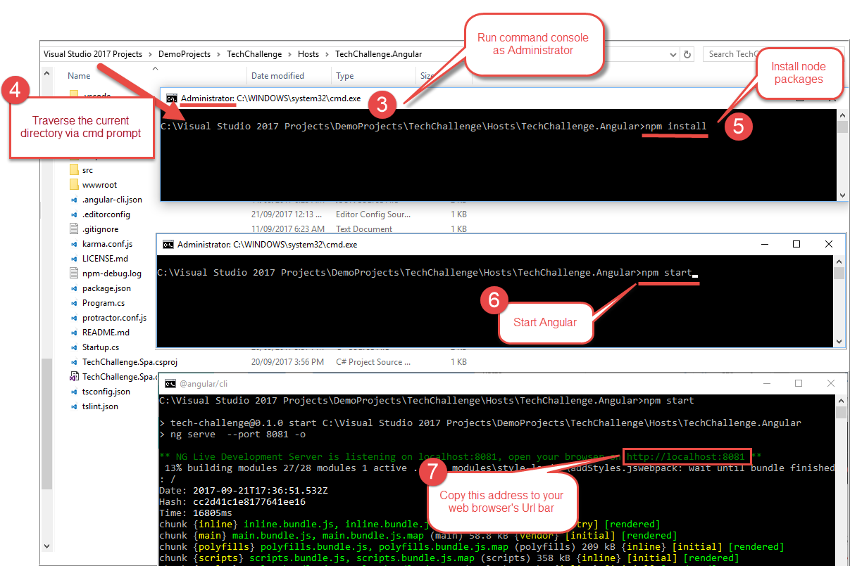

**Note**: Keep the WebApi solution running while browsing the front-end.

# Task 1 - Race Dashboard

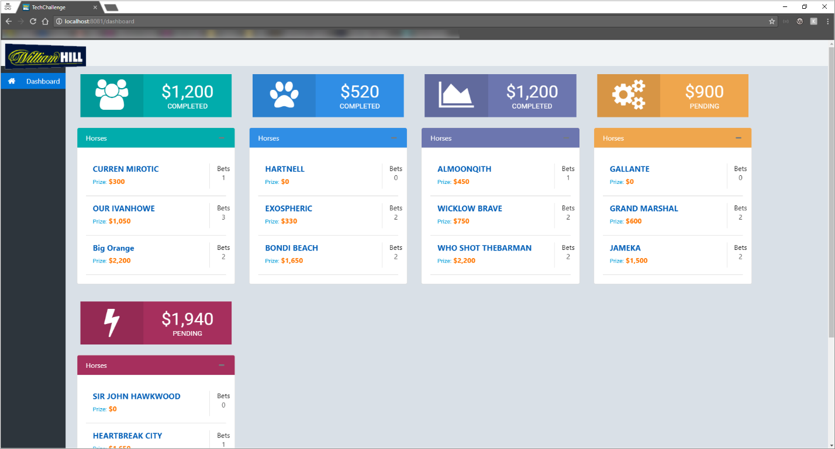

## Race status



## Total amount of money for each race



## All horses per race with name, bet count and winning prize

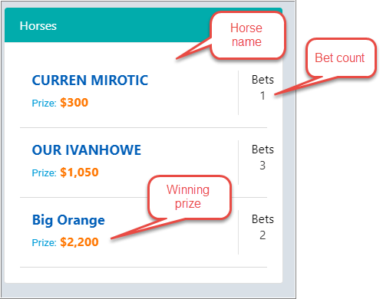

# Task 2 - Additional Endpoints

## List of customers

(http://localhost:44340/api/customers)

## Total bet count per customer

(http://localhost:44340/api/customers/1/betcount)

## Total bet amount per customer

(http://localhost:44340/customers/1/betamount)

## Total bet amount for all customer

(http://localhost:44340/customers/betamount)

## At risk customers (with bets more than $200)

(http://localhost:44340/customers/risks)

# Tests

## TechChallenge.Tests.Unit

## TechChallenge.Tests.Integration